Chapter 4
Generating XML from Relational Data
This chapter shows you several ways to generate XML from an existing relational database. We start by looking at how to represent relational data in XML, then discuss the most common strategies for generating XML, and finally look at some specific tools. We will look at three different methods: Perl’s DBI module, PHP4, and a Java Servlet. If you are not already familiar with XML and SQL, you may want to review the previous two chapters.

Why Generate XML?
Before diving into the how, let’s consider the why for a moment.
There are several reasons you might want to take a relational database and generate an XML version of some or all of the data contained therein:
Mobility of Data
An XML representation of a complete or partial database could be used for a vendor-independent backup, or to move data from one database to another. You would have to write code to load the XML back into the chosen destination database, of course, but the advantage of a single central hub format is that adding a new database format only involves adding two new converters. Here are diagrams of the two methods, first using direct database-to-database translations and then using a central hub format.
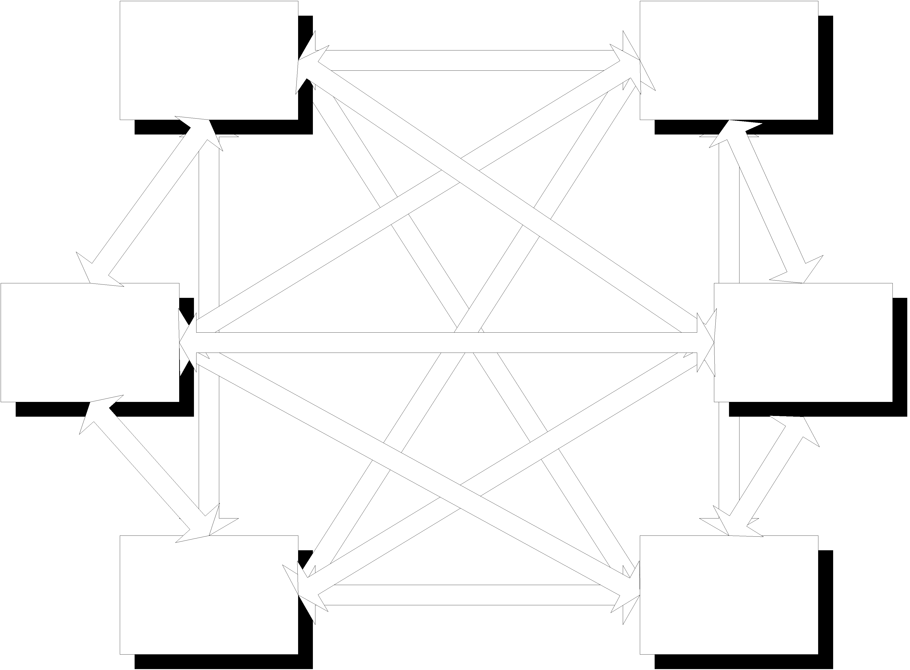
Figure 1: Six databases need 30 filters

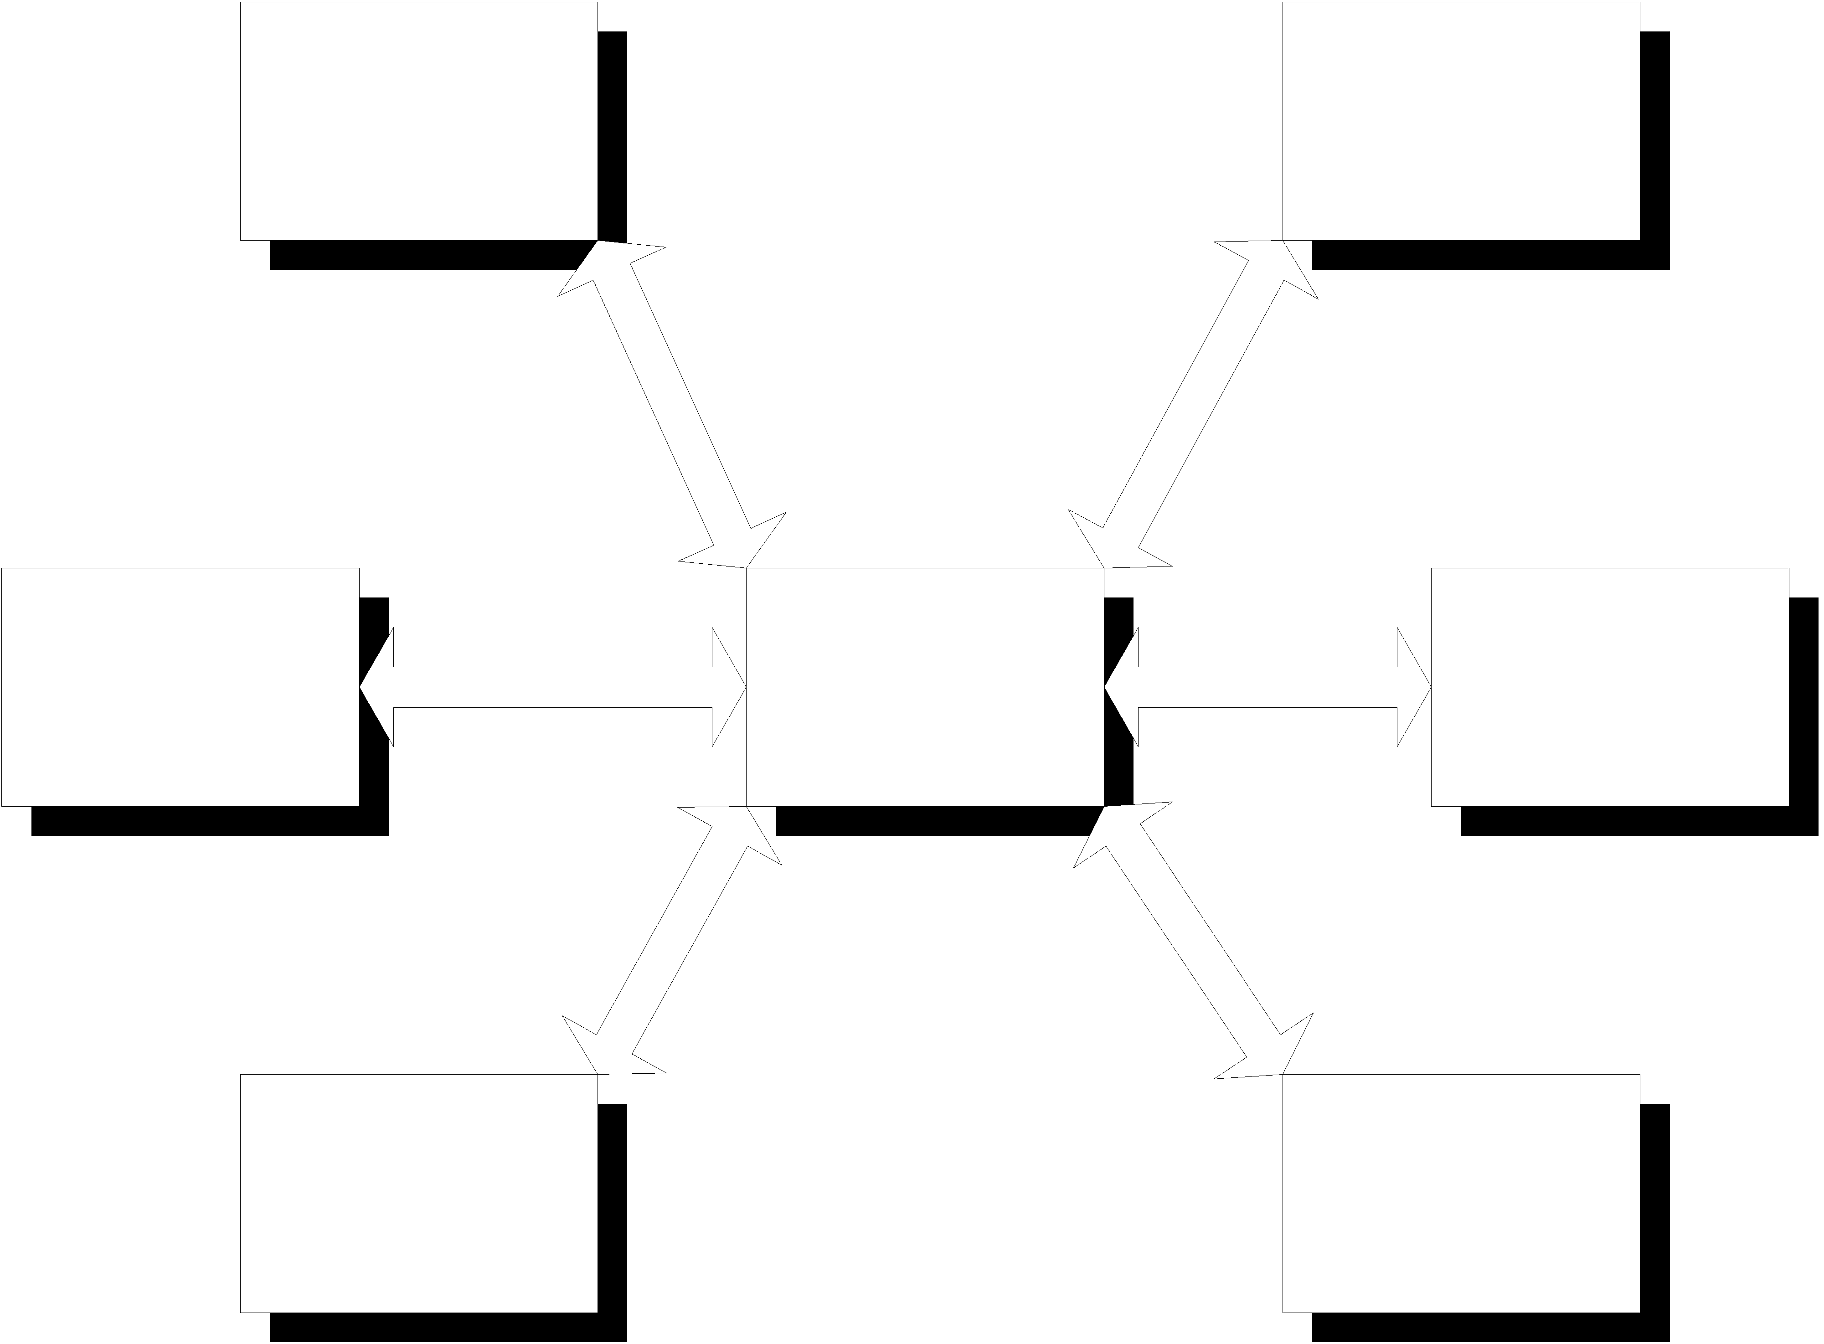
Figure 2: Six databases and a hub: 12 filters
Browser Views
You might want to serve information up on the World Wide Web, taking advantage of browser-specific XML features such as the support in Mozilla or Internet Explorer. Since not all browser support XML at the time of writing, this option is most appealing on an Intranet, where you can control the software people are using. There’s no point in telling people to use Microsoft Internet Explorer on Linux, or if they are sight-disabled and use a screen reader or a Braille terminal.
As more and more browsers support XML directly, however, this option becomes more and more interesting. The Resource Guide at the end of this book lists some browsers and gives pointers to getting started on this route. The PHP 4 discussion in this chapter will also help you here; a PHP script could generate different output depending on whether the client sent an HTTP Accept header for text/xml, for example, or, better, could offer the user a choice and track a session variable.
Databases into Documents
For interoperability with a document-based system, such as the environments we shall consider in Part Two of this book, you could generate XML documents from a relational database and then load those documents into a document repository or an Object Oriented database.
For XML Tools
Exporting information as XML lets you use stand-alone XML-based tools such as formatting or typesetting packages, data analysis or statistics packages, or XML-aware tools such as spreadsheets and word processors.
In this chapter, we consider methods and tools that are suitable for all of these, but we will not show a complete application.

Representing Tables
We will use the BookWeb example from Chapter 2, (Just Enough SQL); for convenience, here is a complete Entity Relationship Diagram for the example:
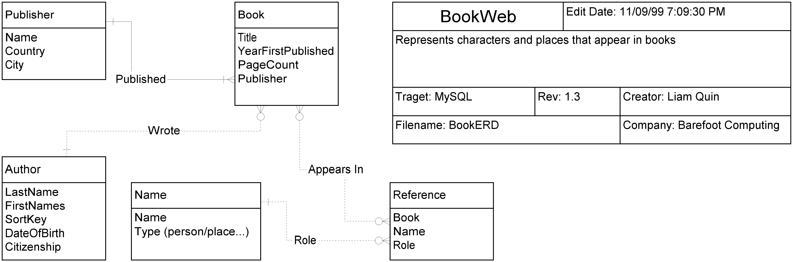
[@@@does this need to be a full figure with a caption and a call-out? This is a 600dpi Tif, I did it with visio, so there are EPS files too. @@@]
Now let’s consider this as an XML document.
Chapter One in this Part, Just Enough XML, described some of the ways XML has of representing relationships. We’ll try considering several approaches for representing our sample data in XML, and then discuss how to get from the database to XML. The examples here are well-formed; we’ll present a DTD after the discussion. In Part five of this book, Metadata, we shall consider how to represent this same database relation using an XML Schema.
Let’s look just at the Reference relation. Here is some sample data, with a single Author and two Books.
First, here’s an extract from Author_tbl:
ID | Author.LastName | Author.FirstNames
183 | Tolkien | J. R. R.
Next, here are two (incomplete) rows from Book_tbl:
ID | Book.Title
901 | The Hobbit
902 | The Lord of the Rings
Now we show that Tolkien wrote those books; this is a many-many relation, so we have a separate table for it:
Wrote.Book | Wrote.Author
901 | 183
902 | 183
Here is a character who appears in these books:
Name.ID | Name.Name | Name.Description
12 | Bilbo | A hobbit, or halfling, a barefoot adventurer.
Bilbo appears in both of our books, but plays different rôles in those two books:
Reference.Book | Reference.Name | Reference.Rôle
901 | 12 | Advisor
902 | 12 | Protagonist

Since this relation contains references to two other tables and a string, we might use something like the following XML fragment to represent the Reference table:
<?xml version="1.0" encoding="ISO-8859-1"?>
<Reference_tbl>
<Reference>
<Book ref=”book901” />
<Name ref=”name12” />
<Rôle>Advisor</Rôle>
</Reference>
<Reference>
<Book ref=”book902” />
<Name ref=”name12” />
<Rôle>Protagonist</Rôle>
</Reference>
</Reference_tbl>
In general, when you first start exporting data from relational tables, you’ll see this model a lot: a single row from a table forming a single element in a table. If your purpose is primarily to represent the table or tables, this is actually about as good as you can get and all you need. It describes the data clearly, and it has not introduced any new concepts. We will use this model again when we consider reading XML in the next chapter.
If you wanted to display this information to a user in a web page, they’d probably be a little disappointed. You would need to do a JOIN or a more complex SELECT, and capture the Name fields from the Book, Author and Names tables too:
<?xml version="1.0" encoding="ISO-8859-1"?>
<Reference_tbl>
<Reference>
<Book ref=”book901”>
<Title>The Lord of the Rings</Title>
<Author>Tolkien, J. R. R</Author>
</Book>
<Name ref=”name12”>Bilbo</Name>
<Rôle>Advisor</Rôle>
</Reference>
<Reference>
<Book ref=”book902” >
<Title>The Hobbit</Title>
<Author>Tolkien, J. R. R</Author>
<Name ref=”name12”>Gandalf</Name>
<Rôle>Protagonist</Rôle>
</Reference>
</Reference_tbl>
This example is much more readable for humans, but it is emphatically not suitable for data archiving or for transfer. It is not in what a database designer would call a Normal Form, because data is duplicated. If you edited this little XML document and then saved it, you might easily make a mistake, such as spelling an author’s name differently in two places. We return to this topic again later, because it’s very central, but for now, suffice to say that you should use a reference to content when a relational table uses a foreign key. Use #PCDATA content (such as Bilbo) only when the data actually appears in the table directly, whether as an INTEGER, VARTEXT or CHAR.
If we were trying to export the whole database, we would probably represent each of the tables as a sequence of elements, just like the References example above. We would end up with a section defining Publishers, another defining Authors, another Books, another Names, another relating authors and books, and a final one relating names and their appearances in specific books.
Here is a sample XML file; we’ll meet it again in the next chapter, with more discussion and a real XML DTD.
<?xml version="1.0" encoding="ISO-8859-1" ?>
<Catalogue>
<AuthorList>
<Author id="a001">
<LastName>Benford</LastName>
<FirstNames>Gregory</FirstNames>
</Author>
<Author id="a002">
<LastName>Coney</LastName>
<FirstNames>Michael Greatrix</FirstNames>
</Author>
<Author id="a003">
<LastName>Brin</LastName>
<FirstNames>David</FirstNames>
</Author>
</AuthorList>
<PublisherList>
<Publisher id="p001">
<Name>Bantam</Name>
<Country>USA</Country>
</Publisher>
<Publisher id="p002">
<Name>Futura</Name>
<Country>UK</Country>
</Publisher>
</PublisherList>
<BookList>
<Book EarliestDate="1983" Publisher="p002">
<Title>The Celestial Steam Locomotive</Title>
<AuthorRef Role="Wrote" Who="a002" />
<Blurb>Alan-Blue-Cloud is pure intelligence, immortal,
ineffable, a being who remembers not only what
was, but what will be. This is his story, set in the
year 143,624 Cyclic, in a future so distant that . . .
</Blurb>
</Book>
<Book EarliestDate="1986" Publisher="p001">
<Title>Heart of the Comet</Title>
<AuthorRef Role="Wrote" Who="a001" />
<AuthorRef Role="Wrote" Who="a003" />
</Book>
<Book EarliestDate="1998" Publisher="p001">
<Title>Heaven's Reach</Title>
<AuthorRef Role="Wrote" Who="a003" />
<Notes>The final book of the second Uplift trilogy</Notes>
</Book>
</BookList>
</Catalogue>
This example does not reduce the Publisher to a normal form, and does not include any names, but it’s enough to illustrate the chapter. The online web site includes a fuller example, with several hundred books described.
A very different approach is to generate an entire document. For example, given the Tolkien data earlier, we could generate something like this:
<BookDescription>
The writer J. R. R Tolkien wrote both <title>The Hobbit</title> and
<title>The Lord of the Rings</title>. Bilbo appears as protagonist
in <title>The Hobbit</title> but as advisor in <title>The Lord
of the Rings</title>.
</BookDescription>
This sort of text generation requires a lot more thought, and the techniques are beyond the scope of this book, but if you are trying to generate human-readable reports or documents, the possibility has to be considered.
Generating XML with DBI
We have seen some ways to represent XML; now let’s look at ways to generate this from a database.
First, let's write a simple Perl script that connects to a database and prints out a single table.
If you type this example in yourself, you may need to change the first line to reflect the location of Perl 5 on your system; on FreeBSD, for example, it's probably /usr/local/bin/perl5 instead of /usr/bin/perl. Comments starting with # [ ...] are intended to help readers of the book; there's no need to type them. You can leave out all the comments except the very first line, if you like, but that's not usually a good idea, as they are there to make the program easier to read.
#! /usr/bin/perl -w
use strict;
The "use strict" declaration turns on stricter error checking. Although it takes longer to get your program to run, because you have to fix all the errors, those errors would quite likely have made the program go wrong. ]

# This program requires the DataBaseInterface package, DBI:
use DBI;

If you are not using mysql, you will need to change the next two lines. try "perldoc db" for more information. At the time of writing, DBI supports a wide range of databases, both free and commercial.
my $driver = "mysql";
my $port = 629; # default for mySQL

# Specify the computer running the database.
You can use "localhost" if it's running on the same machine as this perl script. If "localhost" appears not to work, try "127.0.0.1", and then see http://www.localhost.com/ for how to fix your domain name server (DNS) configuration.
my $host = "localhost";

The script will try to connect to the database using the user and password given here. In a shared environment, the script should prompt the user for a password instead.
Note that $user is a database user, NOT a Unix user. They might be the same, but often aren't; even if they are the same, the passwords might be different. A common error is giving an incorrect username or password.
my $password = "n0tshown";
my $user = 'liam';

# The name of the database to connect to:
The database name is case sensitive in some implementations, including mySQL on Unix. You should always refer to a database by exactly the same name you used when you created it, even if your database doesn't distinguish between upper and lower case. Then your scripts will work on other systems if you have to move them.
my $database = "books";

# Now let's connect to the database
my $dbh = DBI->connect(
"DBI:$driver:database=$database;host=$host;port=$port",
$user,
$password
);

if (!defined($dbh)) {
die "could not connect to database $database on $host:$port - $!";
}

Now we are connected. Production code might do better error handling, such as waiting for a few seconds and trying again, or maybe trying a secondary database, perhaps analysing the error to determine what to do.
This example code leaves out most error checking because otherwise the code would be too long, and no-one would read it, but 70% or more of production code is often taken up by error handling.
# Now build an SQL query andrun it

# First make a query. This is a pretty simple query!
my $sth = $dbh->prepare("SELECT * FROM books.Author_tbl;");

# run the query:
$sth->execute;
Again, note the lack of error cheking here!

# now let's find out some things about the result...
# the number of rows in the result:
my $numRows = $sth->rows;

# fetch the names of the columns:
my $names = $sth->{'NAME'};
This innocuous-looking statement is worth an explanation... we are calling the NAME method of the sth object. This method is documented as returning a reference to an array. If you are not familiar with references in the Perl language, try running "perldoc perlref" to get started. The idea is that $names now holds a representation of the name of an array (actually a pointer), so that @{$names} is the actual array. This means that ${$names}[0] is the first element of the array in question. Perl lets us write that as $$names[0].

# How many columns are there in the result?
my $numFields = $sth->{'NUM_OF_FIELDS'};

# Print out a container for the result:
print "<Result rows=\"${numRows}\">\n";

# Now print out the data, one row at a time.
while (my $ref = $sth->fetchrow_arrayref) {
# Since this is Author_tbl, we could use <Author> for
# the rows, or we can just use <row>, as here.
print " <row>\n";

# Now the individual fields.
for (my $i = 0; $i < $numFields; $i++) {
if (defined($$ref[$i])) {
print " <$$names[$i]>$$ref[$i]</$$names[$i]>\n";
}
}
print " </row>\n";
}
print "</Result>\n";

# now free the resources used by that query:
$sth->finish;

# finally, disconnect from the database:
$dbh->disconnect;
You could simply reply on Perl's garbage collection to disconnect from the database, but that is not good practice.
This is a pretty simple example. When it is run on the sample database, it produces output like this:
<Result rows="239">
<row>
<Author_id>10</Author_id>
<LastName>Abbott</LastName>
<FirstNames>Edwin A.</FirstNames>
<Sortkey>Abbott, Edwin A.</Sortkey>
</row>
<row>
<Author_id>20</Author_id>
<LastName>Adams</LastName>
<FirstNames>Douglas</FirstNames>
<Sortkey>Adams, Douglas</Sortkey>
</row>
<row>
<Author_id>30</Author_id>
<LastName>Adams</LastName>
<FirstNames>Richard</FirstNames>
<Sortkey>Adams, Richard</Sortkey>
</row>
. . .
lots more output
</Result>
If you have loaded the sample database from the Web Site or CD-ROM, you will get several hundred rows of output from running this script; the actual output may differ slightly from that shown here, however. The fields you see may also differ slightly if you take the sample from the web page, since it is a live project.
If you are looking at this and thinking it’s much larger than a comma-separated-value (CSV) file, or a tab-delimited one, you’re right. But if you compress this file with Unix bzip2 or gzip, you’ll find the difference in size is pretty negligible, often less than 5%, because the adaptive compression programs can represent the repeating sequences of markup very compactly.
Size is much less important than quality. The explicitly named start and end tags in XML mean that a transmission error can often be detected automatically, which is very important when you’re dealing with databases. If you gave each row element a sequence number attribute, you could detect missing rows too.
One possible error not dealt with in this example is the case in which a field contains a < sign. Clearly if an Author’s name were to contain "</row>", all sorts of havoc would break loose. One way to deal with this is to change the inner loop of the perl script from
# Now the individual fields.
for (my $i = 0; $i < $numFields; $i++) {
if (defined($$ref[$i])) {
print " <$$names[$i]>$$ref[$i]</$$names[$i]>\n";
}
}
to
# Now the individual fields.
for (my $i = 0; $i < $numFields; $i++) {
if (defined($$ref[$i])) {
print " <$$names[$i]>" .
xmlquote($$ref[$i]) . "</$$names[$i]>\n";
}
}
and to supply an extra function:
sub xmlquote($)
{
my $input = shift;
# quote XML markup characters in the input
$input =~ s/\&/\&amp;/g;
$input =~ s/</\&lt;/g;
$input =~ s/>/\&ht;/g;
return $input;
}
This xmlquote subroutine is general enough to be used in other programs, too. Coincidentally, it also works for quoting HTML.
Generating XML for a web browser: CGI
The example Perl script in the preceding section is very close to a working CGI script.
Let's finish it off and try it!
Just Enough CGI
If you are not familiar with the Common Gateway Interface, this brief summary will help. There is nothing mystical or complex about it, but if Rob McCool had not given it a name, perhaps it would never have been popular! If you write CGI scripts over breakfast, skip to the next section, DBI and CGI.
The idea is simply this:
A web server such as Apache can be configured so that when a client connects and requests a particular URL, instead of looking for a file, the server runs a program and returns to the client the output of that program. The program can be written in any language and can do anything it likes. This is not the same as letting external users run any program on your computer! The web server's configuration file lists which programs can be run; usually it's files with names ending in ".cgi" or that are in a directory whose name is "cgi-bin".
The external program -- the CGI script -- is passed a number of environment variables. These are all listed in the Information section of this boo's Resource Guide, but the important ones are set out below, assuming that the CGI program is called classmates and the following (fictional) URL was requested:
http://www.holoweb.net/~lee/classmates/1974/boys?name=simon&wantpic=yes
[@@prod: please don't split that line, if it doesn't fit I'll make a shorter example! Liam @@]
REMOTE_ADDR The Internet Address (IP) of the client making the request, as an ASCII string in dotted format (e.g. 127.0.0.1)
HTTP_USER_AGENT The name of the software the client is using, if the browser sent it.
SERVER_PROTOCOL The Protocol part of the requested URL, usually "http".
SERVER_NAME The name of the machine running the web server, or its Internet address.
SERVER_PORT The Internet port number used to connect to the server; this is usually 80.
SCRIPT_NAME The URL of the script on this server: /~lee/classmates in this case.
PATH_INFO The part of the URL after the program name; /1974/boys in this case; notice how the user (and the browser) can't actually tell from the URL whether the CGI program is classmates, 1974 or boys, or maybe even none of the above.
QUERY_STRING The query part of the URL: everything that follows the question mark. In this case, that's "name=simon&wantpic=yes"
If the URL was fetched with an HTTP GET request, there is a limit of around two thousand bytes on the length of the URL, including all query parameters. For sending longer data to the server, you have to use a POST or PUT method; the method used is available as REQUEST_METHOD.
If a POST method was used, CONTENT_LENGTH contains the number of bytes that the CGI program can read from its input.
Finally, note that a fragment identifier (in the form of #xxx at the end of a URL) is never passed back to the web server; instead, the browser removes the #xxx, fetches the document and then searches for <a name='xxx'> in the document.
The output of the script should normally be an HTTP header followed by a blank line, followed by data. The following Unix shell script is a useful example:
#! /bin/sh

# print the header:
cat <<EOF
Content-type: text/html

<head><title>CGI Example</title></head>
<body
bgcolor="white"
text="black"
link="blue"
>
EOF

# deduce and then print our URL:
URL="http://${SERVER_NAME}"
if [ ! -z "${SERVER_PORT} -a "$SERVER_PORT} -ne 80 ]
then
URL="${URL}:${SERVER_PORT}"
fi

URL="${URL}${SCRIPT_NAME}"

if [ ! -z "$PATH_INFO" ]
then
URL="${URL}${PATH_INFO}"
fi

if [ ! -z "$QUERY_STRING" ]
then
URL="${URL}?${QUERY_STRING}"
fi

# print the result:
cat <<EOF
<p>The URL of this script is:</p>
<form method="$REQUEST_METHOD" ACTION="$URL">
<pre>${URL}</pre>
<input type="text" name="name" value="simon">
<input type="SUBMIT" value="Try Again">
</form>

<hr>

EOF

if [ ! -z "$*" ]
then
echo "<h2>Arguments:</h2>"
for i
do
echo "<pre> \"$i\"</pre>"
done
fi

echo "<h2>Environment</h2>"

echo "<pre>"
set
echo "</pre>"

# end the HTML document:
echo "</body></html>"

Here is an example of the output you might see:
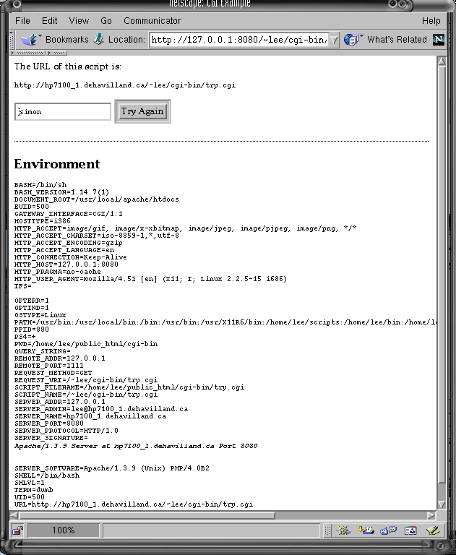
Figure N: Possible output from sample CGI script

Debugging CGI Scripts
It'd be awfully unfair of me to introduce you to CGI scripts without warning you that they are easy to get wrong. Here are some times for fixing them.
If you are working with CGI, Perl, a database, SQL, XML and an HTTP client, there are a lot of factors present. The first trick is to try to eliminate as many sources of error as possible.
Do CGI Scripts work?
If you have already got a copy of the try.cgi program, run it by telnetting to the machine running httpd and type an HTTP request:
$ telnet 127.0.0.1 8080
Trying 127.0.0.1...
Connected to 127.0.0.1.
Escape character is '^]'.
GET /~lee/cgi-bin/try.cgi HTTP/1.1
Accept: */*
Host: 127.0.0.1
Press Return twice to make a blank line
You should see some output like this (my web server is running on port 8080, so that's the port I'll use in the example):

HTTP/1.1 200 OK
Date: Mon, 20 Sep 1999 02:55:16 GMT
Server: Apache/1.3.9 (Unix) PHP/4.0B2
Connection: close
Transfer-Encoding: chunked
Content-Type: text/html
193
Content-Type: text/html
6b
<head><title>CGI Example</title></head>
<body
bgcolor="white"
text="black"
link="blue"
>
124
<p>The URL of this script is:</p>
<form method="GET" ACTION="http://hp7100_1.dehavilland.ca/~lee/cgi-bin/try.cgi">
<pre>http://www.holoweb.net/~lee/cgi-bin/try.cgi</pre>
<input type="text" name="name" value="simon">
<input type="SUBMIT" value="Try Again">
</form>
<hr>
15
<h2>Environment</h2>

and so forth. The numbers indicate the number of bytes to follow; this is an optional feature of HTTP 1.1; you may not see them. The important thing to look for is that you get the right output. If it works, this test shows that the web server is listening on the right port; if you get the correct output, it also shows that any problems you are having might be in your web browser configuration and not at the server end.

404 Forbidden, or Not Found
If you get this error, make sure your CGI script file has the right modes. If it is in a scripting language such as Perl, it must be readable to the user running the web server (usually "nobody") as well as executable.
$ ls -l try.cgi
-rwxrwxr-x 1 lee lee 947 Sep 19 22:37 try.cgi
Make sure that the directory has the same modes too. You can use
$ chmod 755 try.cgi .
to fix them if necessary.
If it still doesn't work, check the server error log. This is a text file where error messages are logged; for FreeBSD it's usually in /var/log/httpd-errorlog and for Red Hat Linux this is usually in /var/log/httpd/error-log. It's useful to run tail -f /var/log/httpd/error-log in a separate window while you're developing CGI scripts, because then you'll see the errors as they happen.
An error such as the following might show you that you've put the cgi script in the wrong place (it probably needs to be in $HOME/public_html/)
[error] File does not exist: /home/lee/public_html/try.cgi
This isn't the place to list all the error messages you might see in this file; see http://www.apache.org/ or consult the documentation for your web server if it's a different one.
I See the Source!
If your web server returns the source of the CGI script instead of running it, you need to edit the server configuration file. There are usually comments inside it telling you what to do. Look in /etc/apache, /etc/httpd or /usr/local/apache for a directory called conf, and edit the file httpd.conf to add the option ExecCGI to your CGI directory.
Malformed Errors from Script
This error almost always means that your script produced an error message on standard error, or that it printed something (perhaps a debugging message) before the Content-type line. You also get this error if you forget the blank line between the header and the actual data.
DBI and CGI
Enough with explaining CGI! Let's write a simple CGI script that will return any table in the Books database. The Web server will call our program, which is written in Perl and uses the DBI module to contact mySQL. Figure XXX shows this.
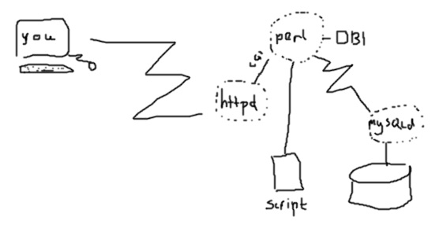
Figure XXX CGI architecture
The first version of the script always prints the same table; see the Exercises at the end of the chapter, and the Resource Guide, for ways to make it take an option, table, to print. If you do this, remember that you may want to restrict the choices, for security, by having the Cgi script check its input very carefully!
Here is the simpler CGI script; it's very like the previous standalone script.
#! /usr/bin/perl -w
use strict;
use DBI;

my $startedHTML = 0; # set to 1 after we begin the header

sub header($$)
{
my ($title, $bgcolor) = @_;

print "Content-type: text/html\r\n";
$startedHTML = 1;
# blank line at end of HTTP header:
print "\r\n";
print <<EOF;
<html>
<head>
<title>${title}</title>
</head>
<body
bgcolor="${bgcolor}"
text="#000000"
link="#3333FF"
vlink="#666699"
alink="#FFFFFF"
>
EOF
}

sub fail($)
{
my $errorMessage = shift;

if (!$startedHTML) {
header("Error", "red");
}
print <<EOF;
<h1>Error</h1>
<p>${errorMessage}</p>
EOF
# although there was an error, we exit(0) because the script
# actually ran OK, and we don't want the http server to
# log an error in the httpd-errors log file. (Not all do)
exit(0);
}

sub xmlquote($)
{
my $input = shift;

$input =~ s/\&/\&amp;/g;
$input =~ s/</\&lt;/g;
$input =~ s/>/\&gt;/g;
return $input;
}

# config parameters:
my $driver = "mysql";
my $port = 629; # default for mySQL
my $host = "localhost";

my $database = "books";

my $password = "nakedb0y";
my $user = 'lee';

my $table = "Author_tbl";

my $dbh = DBI->connect(
"DBI:$driver:database=$database;host=$host;port=$port",
$user,
$password
);

my $sth = $dbh->prepare("SELECT * FROM books.Author_tbl;");
$sth->execute;

my $numRows = $sth->rows;
my $numFields = $sth->{'NUM_OF_FIELDS'};

# We've already shown generating XML, so we will
# generate an HTML table this time.
# When you've got this working, you can change the
# Content-type to text/xml and start changing the tags...

header("XML Book Example/${table}", "white");

print "<h2>Result for ${table}, rows=\"${numRows}\"</h2>\n";

print "<table>\n";

# a table heading
my $names = $sth->{'NAME'};
foreach (@$names) {
print "<th lign='left' bgcolor='#CCCC99'>";
print "<b>$_</b>";
print "</th>";
}

while (my $ref = $sth->fetchrow_arrayref) {
print " <tr>\n";
for (my $i = 0; $i < $numFields; $i++) {
if ($$ref[$i]) {
print " <td>";
print xmlquote($$ref[$i]);
print "</td>\n";
}
}
print " </tr>\n";
}
print "</table>\n";

$sth->finish;
$dbh->disconnect;

exit(0);

And here is some sample output:
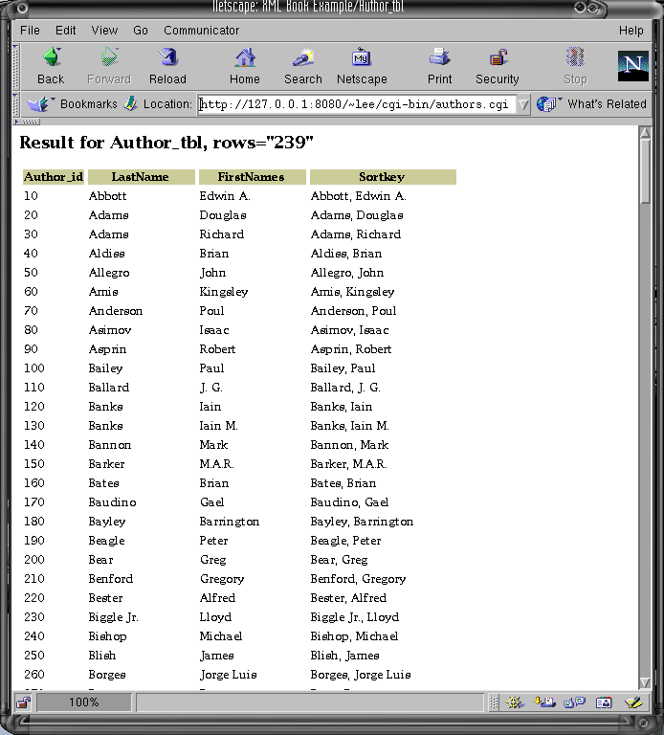

Using PHP
Now that we've seen how easy it is to use a CGI script, we'll move on to look at PHP. "PHP" doesn't seem to stand for anything useful, by the way.
PHP is a language for writing active web pages, a bit like Cold Fusion except non-proprietary, open source, freely available, and without glossy marketing literature and slick development environments. PHP normally runs as a module inside Apache, as shown in Figure XXX.
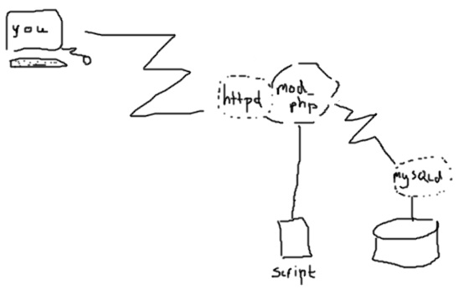
Figure XXX: PHP Architecture
There are some significant advantages to using PHP over using Perl with CGI, and a couple of disadvantages.
Advantages:
- Since PHP is a module that's resident inside the web server, it's much faster than starting perl for each request.
- The PHP language is smaller than Perl, and hence may be easier to learn.
Disadvantages:
- PHP is not quite such a widespread language as Perl; at the time of writing there are only one or two books on PHP (one of which appears to do little more than reprint the documentation that you probably already have in /usr/doc or that's on http://www.php.org/).
- PHP is not so powerful as perl.
- CGI scripts can be in any language; earlier, we saw an example that was a Unix shell script, and a C program could also be used.
None the less, PHP is very widely used, and it's pretty easy.
Example
For the example in this section, you need to make sure that you have a version of PHP configured to use mySQL; if you don't, the Resource Guide has some notes on how to find out how to do this -- it takes about an hour, including compile time.
The example should be saved in a file called names.php (or, if you are using PHP 3, the previous release of PHP, the file should be called names.php3 until you upgrade!).
<html><head><title>books</title></head>
<body>
<?php

$host = getenv("HTTP_HOST");

if (!$host || strcmp($host, "") == 0 ) {
$port = getenv("SERVER_PORT");
if (!$port) {
$port = 80;
}

$server = getenv("SERVER_NAME");
if (!$server) {
$server = getenv("SERVER_ADDR");
}
if (!$server) {
$server = "localhost";
}
$host = "${server}:${port}";
}

$scriptpath = getenv("SCRIPT_NAME");
$url = "${host}${scriptpath}";

function cell($result, $row, $name)
{
echo " <td valign=\"top\">";
echo mysql_result($result, $row, $name);
echo " </td>";
}

function book_details($book_id)
{
}

function find_name_info($name, $name_id)
{
if ($name_id != "") {
$where = "Name_tbl.Name_id = $name_id";
} else {
$where = "Name_tbl.Name REGEXP '$name' ";
}

$query = "SELECT
Name_tbl.Name as Name,
Name_tbl.Type as Type,
Name_tbl.Description as Description
FROM
Name_tbl
WHERE
$where
";

$result = mysql_db_query("books", $query);

if (!$result) {
echo "name lookup for [$name/$name_id] failed.";
} else {
$count = mysql_numrows($result);

echo "<h3>result count: $nums</h3>\n";

echo "<table>\n";
for ($i = 0; $i < $count; $i++) {
echo " <tr>\n";
$type = mysql_result($result, $i, "Type");
echo "<td>\n";
echo "<img src=\"icons/${type}.gif\" width=\"32\" height=\"32\" alt=\"${type}:\">";
echo "</td>\n";
cell($result, $i, "Name");
cell($result, $i, "Description");
echo " </tr>\n";
}
echo "</table>\n";
}

}

function find_books($author, $author2, $title, $eariest, $latest)
{
# mode==booksearch
# the following variables might be set:
# author
# author2 (not done)
# title
# earliest
# latest
# name
$where = "";
$and = "";

if ($author != "") {
if (ereg("(.*) *, *(.*)", $author, $names)) {
$where = "Author_tbl.LastName REGEXP '$names[1]'
AND Author_tbl.FirstNames REGEXP '$names[2]'";
} else {
$where = "Author_tbl.LastName REGEXP '$author'";
}
$and = "AND \n";
}

if ($title != "") {
$where = "$where $and Book_tbl.Title REGEXP '$title'";
$and = "AND \n";
}

# if ($earliest != "") {
# $where = "$where $and Book_tbl.date >= $earliest";
# $and = "AND";
# }

# if ($latest != "") {
# $where = "$where $and Book_tbl.date <= $latest";
# $and = "AND";
# }

# make sure $where is not null:

$query = "SELECT
Author_tbl.LastName as Author,
Author_tbl.FirstNames as firstName,
Book_tbl.Title as Title,
Book_tbl.Book_id as Book_id
FROM
Wrote_tbl, Author_tbl, Book_tbl
WHERE $where $and Wrote_tbl.Author_id = Author_tbl.Author_id
AND Wrote_tbl.Book_id = Book_tbl.Book_id
AND Author_tbl.Author_id = Wrote_tbl.Author_id
";
echo "<h2>books!</h2>\n";

echo "<pre>$query</pre>\n";

$result = mysql_db_query("books", $query);

if (!$result) {
echo "query failed.";
} else {
$count = mysql_numrows($result);

echo "<h3>result count: $count</h3>\n";

if ($count <= 0) {
echo "<p>There were no matches for ";
if ($name_id != "") {
echo "name id $name_id";
} else {
echo "name $name";
}
echo "</p>\n";
}
echo "<table>\n";
for ($i = 0; $i < $count; $i++) {
echo " <tr>\n";
echo "<td valign=\"top\">";
$r_name = mysql_result($result, $i, 'Author');
echo "<b>$r_name</b>";

$r_first = mysql_result($result, $i, 'firstName');
if ($r_first != "") {
echo ", $r_first";
}
echo ":";
echo "</td>\n";

echo "<td valign=\"top\">";
$r_title = mysql_result($result, $i, 'Title');
$r_id = mysql_result($result, $i, 'Book_id');
$info = "<a href=\"http://${url}?mode=book&bookid=${r_id}\">[details]</a>";
echo "<i>$r_title</i> $info";
echo "</td>\n";

echo "</tr>\n";
echo "<tr><td> </td>";
echo " </tr>\n";
}
echo "</table>\n";
}

}

function find_books_with_name($name, $name_id)
{
# the following variables might be set:
# name
# name_id

if ($name_id) {
$where = "References_tbl.Name_id = $name_id
AND Name_tbl.Name_id = $name_id";
} else {
$where = "Name_tbl.Name REGEXP '$name'
AND Name_tbl.Name_id = References_tbl.Name_id
";
}

$query = "SELECT
Author_tbl.LastName as Author,
Author_tbl.FirstNames as firstName,
Book_tbl.Title as Title,
Book_tbl.Book_id as Book_id,
Name_tbl.Name as Name,
Name_tbl.Type as NameType,
Name_tbl.Description as NameDesc,
References_tbl.Role as Role
FROM
References_tbl, Wrote_tbl, Author_tbl, Book_tbl, Name_tbl
WHERE $where
AND References_tbl.Book_id = Book_tbl.Book_id
AND Wrote_tbl.Author_id = Author_tbl.Author_id
AND Wrote_tbl.Book_id = Book_tbl.Book_id
AND Author_tbl.Author_id = Wrote_tbl.Author_id
";

# echo "<pre>$query</pre>\n";

$result = mysql_db_query("books", $query);

if (!$result) {
echo "query failed.";
} else {
$count = mysql_numrows($result);

echo "<h3>result count: $count</h3>\n";

if ($count <= 0) {
echo "<p>There were no matches for ";
if ($name_id != "") {
echo "name id $name_id";
} else {
echo "name $name";
}
echo "</p>\n";
}
echo "<table>\n";
for ($i = 0; $i < $count; $i++) {
echo " <tr>\n";
echo "<td valign=\"top\">";
$r_name = mysql_result($result, $i, 'Author');
echo "<b>$r_name</b>";

$r_first = mysql_result($result, $i, 'firstName');
if ($r_first != "") {
echo ", $r_first";
}
echo ":";
echo "</td>\n";

echo "<td valign=\"top\">";
$r_title = mysql_result($result, $i, 'Title');
echo "<i>$r_title</i>";
echo "</td>\n";

echo "</tr>\n";
echo "<tr><td> </td>";
echo "<td>";
$r_name = mysql_result($result, $i, 'Name');
$r_role = mysql_result($result, $i, 'Role');
$r_type = mysql_result($result, $i, 'NameType');
$r_desc = mysql_result($result, $i, 'NameDesc');
if (strcmp($r_type, "person") == 0) {
echo "Role of $r_name in this book: $r_role";
} else if (strcmp($r_type, "wizard") == 0) {
echo "Role of $r_name in this book: $r_role";
} else {
echo "$r_name, $r_desc, is ${r_role}.";
}
echo "</td></tr>\n";
echo " </tr>\n";
}
echo "</table>\n";
}
}

?>

<!--* possible dumb mode section if mode is unset *-->
<?php if ($name == "" && $name_id == "" && $mode == ""): ?>
<?php echo "<form action=\"http://$url\" method=GET>\n"; ?>
<table>
<tr valign=top>
<th align=right>Character or Place:</th>
<td><input width=20 size=20 name=name></td>
</tr>
<tr>
<td> </td>
<td><input type=submit value="search"></td>
</tr>
</table>
<?php endif ?>
<!--* end of dumb mode section, if present *-->

<--* results section *-->

<?php
mysql_connect("localhost", "lee", "nakedb0y");

if (strcmp($mode, "booksearch") == 0) {
find_books($author, $author2, $title, $eariest, $latest);
} else if (strcmp($mode, "book") == 0) {
book_details($book_id);
} else if ($name != "" || $name_id != "") {
echo "<h1>Books mentioning $name</h1>";
find_name_info($name, $name_id);
}

if ($name != "" || $name_id != "") {
find_books_with_name($name, $name_id);
}

?>

</body></html>

Java
This section gives a brief overview of using Java and JDBC to export data. This is not primarily a Java book, since there are lots of those. If you are in a Java environment already, you might find the strategies presented here useful, and won't want the sample code. You should also look at the Java section of the Resource Guide at the back of the book for useful links to online resources dealing with XML and Java.
If you are not already using Java, there is no "Just Enough Java" section; go to your bookshop and get a tutorial on java such as The Java Tutorial by Mary Campione and Kathy Walrath (Addison Wesley; get the most recent edition) or look for something more specific to your needs.
The techniques in Java as the same as for Perl; you print pointy brackets around things. Another possibility is to write a class that builds objects in memory, perhaps using a SAX-compatible interface (SAX is described in the next chapter, Reading XML) so that you can use an off-the-shelf Java class to print out the result as XML.
Using a Java Servlet
The following simple Java Servlet is roughly equivalent to the CGI script shown above, except that it doesn't take a parameter to return a particular table. You can find the original version of this example at the URL given in the comment. [@@ I have to check more carefully about permission, I'm using it because mine didn't work because of (it turns out) a version incompatibility that should be resolved by the time the book is in print; this version works today. The code is marked as freely redistributable though. @@]
This version generates HTML; change the Content-type to text/html and alter tags as appropriate to make XML! You should save the resulting XML to a file and check it with a parser such as XP to make sure it's well-formed.
/**
* Servlet to query Books database by author.
*
* The original sample code was by Daniel.Schneider@tecfa.unige.ch
* 1999 TECFA, and was freeware. In the same spirit, this example
* is in the public domain.
* See http://tecfa.unige.ch/guides/java/staf2x/ex/jdbc/coffee-break/
*
*/

import java.io.*;
import javax.servlet.*;
import javax.servlet.http.*;

import org.gjt.mm.mysql.*;
import org.gjt.mm.mysql.Connection;
import org.gjt.mm.mysql.Statement;
import org.gjt.mm.mysql.Driver;
import org.gjt.mm.mysql.ResultSet;
import org.gjt.mm.mysql.ResultSetMetaData;

import java.sql.*;

public class BookAuthorServlet extends HttpServlet {
Connection con; // The database connection
Statement stmt; // The statement
String queryString = null; // The queryString

public void init(ServletConfig conf) throws ServletException {
super.init(conf);

String username = "nobody";
String password = "xxx";

// Syntax: jdbc:TYPE:machine:port/DB_NAME
String url = "jdbc:mysql://localhost:3306/Books";

try {
Class.forName("org.gjt.mm.mysql.Driver");
// Connect to the database at URL with usename and password:
con = (Connection)
DriverManager.getConnection(url, username, password);
} catch (Exception e) // (ClassNotFoundException and SQLException) {
throw(new UnavailableException(this, "db conenct failed"));
}
}

/**
* service() method to handle user interaction
*/
public void service(HttpServletRequest req, HttpServletResponse res)
throws ServletException, IOException
{
res.setContentType("text/html");
PrintWriter out = res.getWriter();

try {
String title = "Books by Author";
out.println("<html><head><title>Books by Author</title></head>");
out.println("<body><H1>BookWeb demo: Books by Author</H1>");
String queryString = req.getParameter("QUERYSTRING");

if ((queryString != "") && (queryString != null)) {
out.println("<table border>");
Statement stmt = (Statement) con.createStatement();
ResultSet rs = (ResultSet) stmt.executeQuery(queryString);
ResultSetMetaData rsMeta = (ResultSetMetaData) rs.getMetaData();
// Get the N of Cols in the ResultSet
int noCols = rsMeta.getColumnCount();
out.println("<tr>");
for (int c=1; c<=noCols; c++) {
String el = rsMeta.getColumnLabel(c);
out.println("<th> " + el + " </th>");
}
out.println("</tr>");
while (rs.next()) {
out.println("<tr>");
for (int c=1; c<=noCols; c++) {
String el = rs.getString(c);
out.println("<td> " + el + " </td>");
}
out.println("</tr>");
}
out.println("</table>");
}
} catch (SQLException ex ) {
out.println ( "<P><PRE>" );
while (ex != null) {
out.println("Message: " + ex.getMessage ());
out.println("SQLState: " + ex.getSQLState ());
out.println("ErrorCode: " + ex.getErrorCode ());
ex = ex.getNextException();
out.println("");
}
out.println ( "</PRE><P>" );
}

out.println ("<hr>You can now try to retrieve something.");
out.println("<FORM METHOD=POST ACTION=\"/servlet/BookAuthorServlet\">");
out.println("Query: <INPUT TYPE=TEXT SIZE=50 NAME=\"QUERYSTRING\"> ");
out.println("<INPUT TYPE=SUBMIT VALUE=\"GO!\">");
out.println("</FORM>");
out.println("<hr><pre>e.g.:");
out.println("SELECT * FROM Author_tbl");
out.println("SELECT * FROM Name_tbl");
out.println("<pre>");

out.println ( "</body></html>" );
return ;
}
}

Exercises
Study the xmlquote function given near the end of the first code section in this chapter. It first replaces every "&" with "&amp;" in the input. What would happen if it did this last instead of first?
The Java Applet lets users send an arbitrary query. You could encode a fixed set of choices in a web page, but people could gt around that simply by editing the URL, or saving a local copy of the HTML and changing it. How would you code the Servlet to be secure?
@@ more exercises to follow @@
Further Reading
The Resource Guide at the end of the book gives pointers to resources on Perl, and also some of the relevant documentation.
See www.php.org for PHP.
The Servlet API is at java.sun.com.

