Chapter 10
Introduction to Object Oriented Databases
This chapter introduces the basic concepts of object oriented databases. Its purpose is to help you decide whether you should investigate such products further, and to understand how they might work.
The Main Features
Object Oriented Databases generally provide persistent storage for objects. In addition, they may provide one or more of the following: a query language; indexing; transaction support with rollback and commit; the possibility of distributing objects transparently over many servers. These features are described in the following sections. Some database vendors may charge separately for some of these features.
Some Object Oriented Databases also come with extra tools such as visual schema designers, Integrated Development Environments and debuggers.
Context
Unlike a relational database, which usually works with SQL, an object oriented database works in the context of a regular programming language such as C++, C or Java. Furthermore, an object-oriented database may be host-specific, or it may be able to read the same database from multiple hosts, or even from multiple kinds of host, such as a SPARC server under Solaris 8 and a PC under Linux. Some object oriented database servers can support heterogeneous clients, so that the SPARC system and a PC and a Macintosh (for example) might all be accessing the same database.
Persistance
With a relational database, you store information explicitly in tables, and then get it back again later with queries. Although you can use an object oriented database in that way, it's not the only way.
Consider a computer aided design application in which the user can save and load complex engineering drawings into memory. With a file-based system, loading a drawing might involve reading a large external file into memory and creating tens of thousands of objects before the user can start working. With a relational database the software would run database queries to create those same objects.
With an object oriented database, the software calls a database function to load the illustration, but objects are not created in memory until they are needed: instead, they are stored in the database, and only references are loaded into memory.
When an object is changed, the database silently writes the changes to the database, keeping the in-database version up to date at all times. When the user presses "save", all the application does is to commit the current transaction; since the database is already up to date, this is generally very fast. The code no longer needs to be able to read or write the proprietary save file format, and may well also run faster.
Accessing Data
Most of the time, an application using an object oriented database access data by navigation: in C or C++ this is by following pointers, and in Java by following references.
For example, if you have a C++ class representing a tree,
class Tree {
private:
int Value;
Tree *LeftChild;
Tree *RightChild;

public:
Tree *Tree(int Value, Tree *Left, *Right) {
this->Value = Value;
this->LeftChild = Left;
this->RightChild = Right;
return this;
}

Tree *getLeft() { return LeftChild; }
Tree *getRight() { return RightChild; }
int getValue() { return Value; }

Tree *setLeft(Tree *Left) {
return LeftChild = Left;
}

Tree *setRight(Tree *Right) {
return RightChild = Right;
}

int setValue(int V) {
return Value = V;
}

};

// recursive function to visit a tree and add up the values:
int Tree::getTotal()
{
int Result = Value;

if (LeftChild) {
Result += getTotal(LeftChild);
}

if (RightChild) {
Result += getTotal(RightChild);
}

return Result;
}

We might use this as follows:
Tree *myTree = getTree("tree one");

cout << "Total for tree one: " << myTree->getTotal() << "\n";
The getTree function could be implemented by reading a file from disk, but in this chapter, the implementation is probably something like this:
Tree *Tree::getTree(const char *Name)
{
return (Tree *) database::get(Name);
}
This creates a single in-memory Tree object, by restoring a memory image from the database. The OODB will also initialise the two pointers LeftChild and RightChild, but it will not (in general) load the corresponding objects into memory. When getTotal() accesses or dereferences a child pointer, passing it to getTotal(), the database has to load the corresponding object into memory and adjust the pointer in the Tree as necessary.
This pointer manipulation can be achieved in several ways, depending on the database software. The most common way in C and C++ is to use the memprot system function; on Unix, this sends the process a signal whenever a process tries to access unallocated memory. The database runtime support library intercepts the signal, looks to see if the address in question was a database address, and, if so, loads the object into memory and makes the address be legal by changing permission on the corresponding page. Figure 1 shows memory before LeftChild is accessed, and Figure 2 shows memory after LeftChild has been accessed to but before RightChild has been accessed. In Figure 1, the two blank Tree objects are in a block of hardware-protected memory. When that memory is referenced, the tree is filled in and the permission changed; the pointers in the newly filled in object are set to point to a new protected area of memory.
The hardware memory protection used most often relies on the computer's page table; this is the same table that the operating system uses to control virtual memory, and is usually very efficient. Although the figure shows only a single object being initialised, in practice an entire page's worth is usually loaded at the same time for efficiency reasons. A page may be anywhere from a kilobyte all the way up to 64Kbytes on some systems, with the consequence that it can be tricky to get good performance.
In order to store objects in the database and have them managed, you may need to subclass from a Persistent class. Objects that are members of classes not derived from a suitable superclass are transient, and are not stored. When objects containing pointers or references to transient objects are loaded back from the database, the transient pointers may be set to NULL; some databases may force the transient data to persist.
In Java, unless native methods are used, there is no control available over hardware memory access. Instead, references might be created to empty "stub objects" with methods that first load the data and then call the correct object method. In order for this to work properly, these stub objects may need to be the same physical size as the actual objects.
At least one commercial object oriented database for Java (at the time of writing) uses a different policy, and reads all reachable objects into memory whenever an object is loaded. In either case, you need to watch the memory footprint of your application carefully.
Figure 1: Memory before LeftChild has been accessed
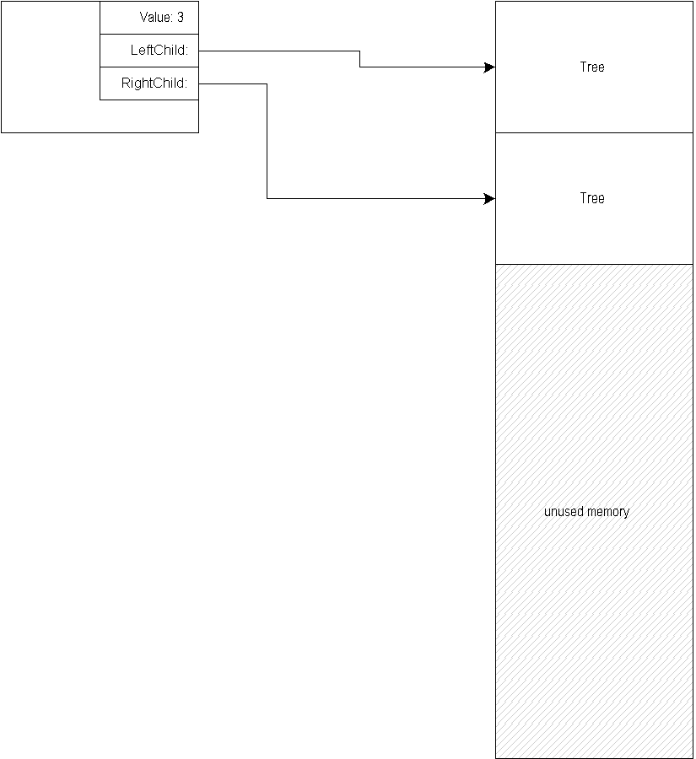
Figure 2: Memory after LeftChild has been accessed
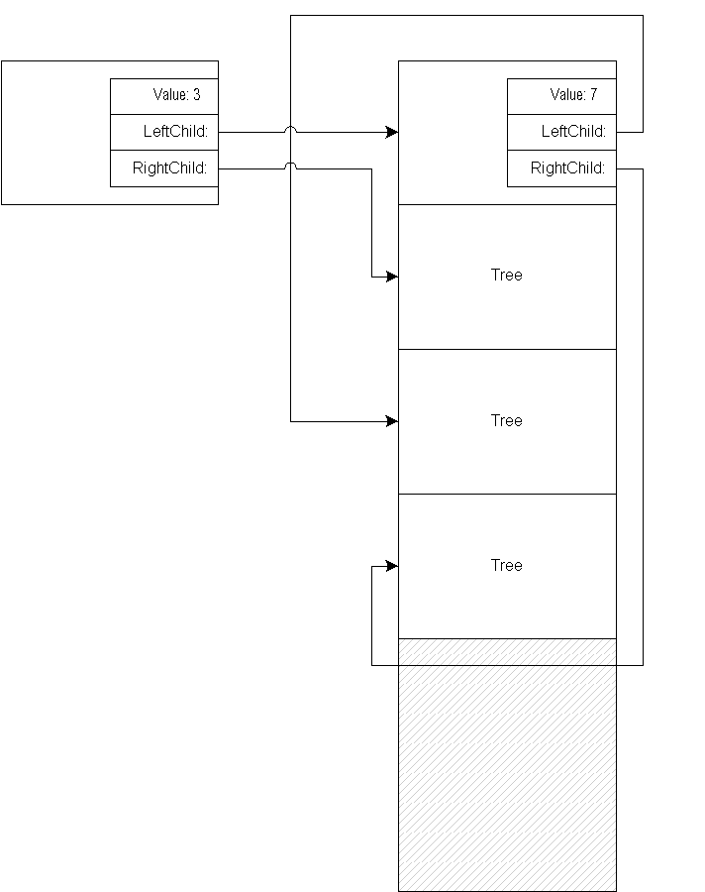
Binding to Objects
The example code assumes that the database runtime support can map from a string to an object. In order to do this, you have to bind the string to the object; you can then retrieve the object at some later time using the string. The string you use more or less corresponds to a file name. Some databases have a noticeable time and space overhead if you start binding thousands (or millions) of objects. Instead, you should bind only a few top-level objects.
You only need to bind a root-level object -- you can follow pointers from that to get to other data.
Saving Objects
Most object-oriented databases save your objects automatically when you finish using them. You may need to delete unwanted objects explicitly, however. Some schemes (especially in scripting languages such as Perl) are more likely to require that you call a save method on objects to write them to disk. If you have to save and load objects yourself, you might ask yourself what other database features you are using, and consider switching to a dynamic hashing package such as ndbm, described in Chapter Twelve.
Queries
You will get the best performance from an object-oriented database if you use a lot of pointer-style navigation and relatively few queries. There is no standard query language for an object-oriented database; the Object Database Management Group (ODMG, an industry consortium) has defined the Object Query Language (OQL), and some vendors support this. A few other vendors (including Object Design Inc., one of the founders of the ODMG) use proprietary query languages instead.
In order to use queries, you may need to give each class some sort of method to print its searchable values. Some systems support queries embedded in C or C++ code, and some allow runtime queries.
Here is an example of an OQL query that appears in the published ODMG 2.0 standard. It's pretty similar to an SQL query, and this is of course by design.
select c.address
from Persons p,
p.children c
where p.address.street="Main Street" and
count(p.children) >= 2 and
c.address.city != p.address.city
This assumes that a Person object contains a child reference (children) that points to another Person instance. The dot notation works rather like C or Java field selection. The query will make the database server (or library) look at every single instance of a Person to see if it has two children, and has a street address of Main Street, and has a child whose address' city field differs from that of its parent.
This query might involve a very large amount of memory in some implementations, as it may involve loading every Person object into memory. If you can build in index on the Persons.address.street field, that might help; it's clear that you need to take care in how you design your objects to work with the object-oriented database you are using. Switching from one such system to another can involve quite a lot of unexpected work. You should make sure that you hide the implementation of persistence as much as possible. This is also good because it means you're less likely to make a mistake such as forgetting to save an object.
Note also that the inequality operator, "!=", might use the address of the city object, or, in a system like C++, an overloaded method, or, in Java, might use object identity. A detailed introduction to the Object Query Language is beyond the scope of this book -- see the Object Database management Group's published book (http:/www.odmg.org/ has the details).
Object Design (http://www.odi.com/), Poet (http://www.poet.com/) and Ardent (http://www.ardent.com/) all provide XML parsers and/or XML storage facilities, as do many others. The resource guide gives pointers to Object Oriented Database vendors.
Indexing
Just as with a relational database, an object oriented database can often create an index so that accessing a particular field can be very fast. In the Tree example above, we could build an index on the Value member, and then use that index to find Tree objects with a specific value very quickly. For this to be useful, you'd probably need to have upward pointers in each tree node as well as downward ones, so that, once you had found a node, you could find the top of the tree containing that node.
Some databases support both hashing and b-trees; others support only one or the other. Some databases can create indexes based on multiple fields, and can return pointers to complex objects; these are usually the databases that also support a query language.
Object Design Inc.'s PSE database for Java is an example of one that supports multiple types of memory access behaviour with its indexing; it has a kind of index that can be searched without loading all of the corresponding objects into memory.
Transactions
As with a relational database, a transaction is a sequence of database operations that must either all complete or all fail. If any of them fails, or if the program calls an abort method or raises an exception, the entire transaction is aborted. Only when the transaction finishes can other database clients see any of the changes. Some databases may lock other threads trying to access data that is being changed in another transaction; this means that there may be a possibility for deadlock, where multiple threads (or programs) are all waiting for each other.
The ODMG specification does not allow nested transactions, although some vendors support them; again, this can increase the chances of deadlock, but it can also simplify programming and design.
If you have multiple threads within an application, each thread might get its own transaction, or you might be restricted to a single transaction per application.
Transactions can be very expensive to implement, and there can be a noticeable performance degradation if they are enabled. This is true with some relational databases too, of course. Use transactions if you need to be able to undo (roll back) a sequence of operations; if all you want is exclusive access for a short time, you might find that the database provides a locking mechanism that's faster and simpler.
For many applications, it is sufficient to allow multiple readers but only a single writer; sometimes all of the readers can happily wait for a single writer to finish. This is most likely to be true if the write operations are fast and relatively infrequent. If you have a lot of small write operations and a few that take longer, consider using a mixed strategy, where the write operations allow readers between them, but the longer operations maybe use a separate transaction so that readers can continue independently in other parts of the database. An example is a database backup, where you might need to disable changes, and where you might mark certain objects (top-level nodes, for example, as having been archived. These changes don't affect most readers, so you could allow other readers in between each write operation, but not allow other writers to come in and confuse your backup state.
Distributed Objects
Some object-oriented databases permit objects to migrate from one database server to another. They might move to the server that requested them most recently, for example. Often the servers can be running different operating systems on different CPU architectures, and the database rewrites the objects as necessary.
This may happen automatically, perhaps with a global cache manager, or you might need to request remote objects explicitly.
Databases that support this may use a lot more disk space to store the same data, because they have to store information about which server contains the master copy for each object.
Summary
An object-oriented database is an entirely different beast from a relational database. It seems like a very natural fit for storing XML objects, although in practice if you decompose your XML to individual elements it's hard to get good performance.
Many relational database programmers are startled and puzzled when they first encounter object-oriented databases: from the perspectives of the database programmer and of the user, the two kinds of database are very dissimilar. An object-oriented database may seem too simple, and one has a disturbing feeling at first that one has missed a hidden catch. But they really are that simple.
The next chapter discusses using object-oriented database with XML.

