XML and XSL
Reading List
Books and printed resources
Graham, Ian S. and Quin, Liam R. E., The XML Specification Guide
The XML Handbook
Markup Technologies, a journal published by the MIT press
Online Resources
W3.org
Xml.com
www.omnimark.com
tcl web site (scripting.org??)
Robin Cover at Oasys
The XML Specification Guide web site
IRC channels??
Newsgroup comp.text.xml
Newsgroup comp.text.sgml

Conferences and Trade Shows
GCA XML/SGML Europe
GCA SGML/XML
GCA Markup Technologies
HyTime thing
XTAG?
Internet World?
International World Wide Web Conference
Related Standards
Xlink and Xpointer
XSL
XQL
SGML
DSSSL

Building expat on Unix
The expat distribution unpacks into the hierarchy shown in Figure XXX.
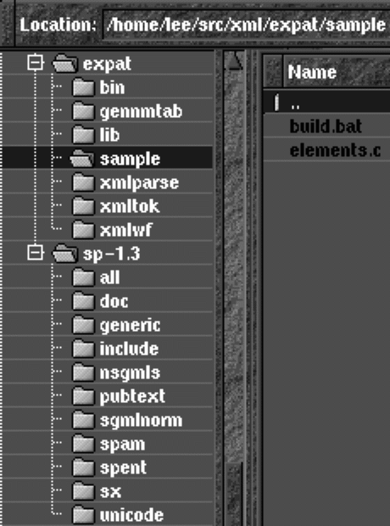
Figure XXX: folder after packing expat. Also shown is the sp-1.3 distribution, which is not required for using expat but is very useful.

The expat parser builds as a set of three libraries, parse, tok and wf.. If you are using Unix, after downloading and unpacking the distribution, you may want to use a Makefile such as this
[TODO xxx]
The author found it easiest, after building the libraries, to rename them:
[TODO xxx]\
The program that follows is called Authors.c and should be placed in the sample directory alongside elements.c and then compiled and run like this:
[TODO xxx]

